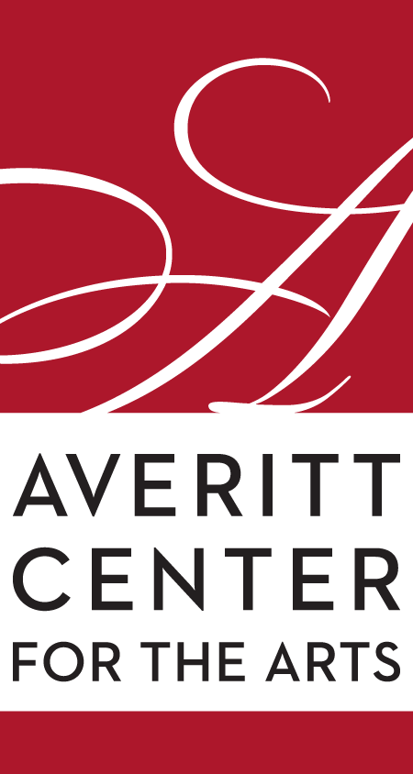
Rahn Hutcheson
Executive Director
Averitt Center for the Arts
P.O. Box 926 • 33 East Main Street
Downtown Statesboro • (912) 212-2787
www.averittcenterforthearts.org
rhutcheson@averittcenterforthearts.org

Christmas is in the air at the Averitt
Visual arts and music come together to make the Averitt Center for the Arts one very busy place in December.
The annual All Fired Up! Holiday Sale kicks off the merry month with one-of-a-kind ceramics, jewelry, paintings and more at the Roxie Remley Center for Fine Arts on Dec. 2-4.
The Averitt Center for the Arts and Georgia Southern University’s Betty Foy Sanders Department of Art (BFSDoA) have teamed up to provide GSU art students with the opportunity to showcase and sell their artwork. Other local and area artists will also display their wares during the three-day event at the 31 East Vine Street location. On Thursday (Dec. 2) doors are open to the public from 2 to 8 p.m. Friday is a day-long event (10 a.m. to 8 p.m.) and Saturday’s sale is from 10 a.m. to 2 p.m.
​ Averitt Center visual art students, GSU's Student Made and Jewelry Guild, professional artists and professors will participate in the event, along with Statesboro Regional Art Association members, local painters and photographers and Roxie Remley studio artists.
The Statesboro Regional Art Association will also be continuing its annual Holiday Small Works Exhibition and Sale down the street at the Rosengart Gallery at 41 West Main. Original artwork and crafts from the association’s membership will be on display and can be purchased on-site. According to SRAA spokesperson Alice Bennett, there will be a wide variety of items.
“At Small Works, all pieces exhibited are for sale and every piece is less than $99,” she said. Bennett added, “The SRAA is offering this sale by presenting smaller paintings and unique handmade arts and crafts at many price points. Shoppers can purchase one-of-a-kind items that make thoughtful, treasured gifts at special budget-friendly prices.”
The Rosengart Gallery is open on Tuesday through Friday from 10 a.m.-2 p.m. and every weekday from 3:30-6 until Dec. 17. Special arrangements can also be made by contacting the Averitt Center at 212-2787.
Doobie Brothers tribute band Brotherhood helps celebrate the 50th anniversary of the eclectic 1970s rockers on Dec. 4 on the Jan Brown Anderson stage of the Emma Kelly Theater.
The eight-piece band of veteran musicians whose love of the Doobies brought them together pay homage to the 2020 Rock and Roll Hall of Fame inductees. Honoring the original sound, Brotherhood will cover the 16 Billboard Hot 100 top-40 hits, including "Listen to the Music", "Jesus is Just Alright", "Long Train Runnin'", "China Grove", "Black Water" (#1 in 1974), "Takin' It to the Streets", "What A Fool Believes" (#1 in 1979), and "The Doctor", all of which remain in heavy rotation on classic rock.
The band includes Drew Jacobs on guitars and vocals, Jim Wojenski on lead guitar, John Broderick on bass guitar and vocals, Chris Godfrey on percussion and vocals, Mike Cotsman on keyboard and vocals, Hal Eisenberg on drums and vocals, Michael Whitlow on drums, and Charity Hitchcock on vocals. Eisenberg has a local connection though his long-standing friendship with Statesboro’s Dr. Al and Debbie Palmer.
Brotherhood is exclusively sponsored by the Joey Cowart Law Firm.
As our community recovers from the pandemic, the series called One: Holiday is preparing a very special holiday show on Dec. 11-12.
A cornucopia of religious and secular music will be presented by the stars of the series. Eight artists from the past three seasons have been invited to perform one or two of their favorites.
The performances, which are sponsored by Brinson, Williams and Groomes Insurance and Savannah Car Rentals of Statesboro, will include songs by Vivian Summers, Shaunta Ellis, Nora Franklin, Brandi Harvey, Eddie Frazier, Michael Braz, Donald Chavers and Robin Holmes-Lanier.
Festive Christmas trees bending in a snow storm are the subject of this month’s Paint-n-Party, sponsored by borotakout.com. The party will be on the 10th from 6-8 p.m. at the Roxie Remley Center for Fine Arts on East Vine Street. No experience is necessary! Just come and have fun with friends and your favorite drink! (21+ to drink). The price includes a 16 x 20 canvas and art supplies that you will use to create your very own masterpiece. Our instructor will guide you through the steps to paint your version of this neat scene.
The Averitt Center offers a wide range of classes for children, teenagers and adults in dance, theater, visual arts and music. The third session of the Visual Art and Theater courses begin January 10 while there are new and existing classes in Dance.
All meet in the late afternoon or early evening (homeschool classes meeting in the late mornings or early afternoons) at one of the three Averitt campuses and meet once or more per week. Classes are grouped by age and ability level. Class tuition varies and members do receive discounts.
To purchase tickets and enroll in classes or workshops, simply visit the Box Office at the Averitt Center Main Gallery (open 9a.m.- 4 p.m. Monday through Friday), call 912-212-2787 or go online at www. averittcenterforthearts.org.

