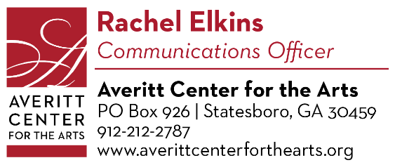
Press Release

November 19, 2022

This Holiday Season, Celebrate the Arts with the Averitt Center

The Averitt Center for the Arts has something for everyone this December! You can look forward to holiday music, laughter, gift-shopping, and, as usual, plenty of chances to express yourself through the arts!

We will kick off the festivities with our Holiday All Fired Up Sale, December 1st-3rd. We hope you saved some of your holiday budget for this! Shop for local one-of-a-kind gifts by our talented, local studio artists and hardworking GSU students, who will come together to display their unique pieces for sale, just in time for the holidays. We’ll have plenty of ceramics, fine arts, jewelry, and more for you to choose from. This sale will take place at our Roxie Remley Center at 31 E. Vine Street. Times are as follows: Thursday 2-8pm, Friday 10am-8pm and Saturday 10am-2pm.

Are you a fan of instrumental or classical music? Well, you’re in luck! On December 6th at 7:30pm, the talented members of the Statesboro Chamber Orchestra will share their musical gifts at the Whitaker Black Box Theater at 41 W. Main Street. This free performance will be led by the orchestra’s longtime conductor, Jonathan Aceto.

December 8th-11th, the Futrelle sisters are coming back to the Emma Kelly Theater, 33 E. Main St., with Christmas Belles. And this time around, they are wishing you a TEXAS CHRISTMAS! But the Futrelles are not exactly in a festive mood. A cranky Frankie (played by Rachel Elkins) is weeks overdue with her second set of twins. Twink (Nichole Deal) is in jail for inadvertently burning down half the town. And hot-flash suffering Honey Raye (Julie Moody) is desperately trying to keep the Tabernacle of the Lamb’s Christmas Program from spiraling into chaos. Things are not looking good…especially when Frankie lets slip a family secret that has been carefully guarded for decades. However, in true Futrelle fashion, the feuding sisters find a way to pull together to present a Christmas program the citizens of Fayro will never forget.

Your favorite characters are back: Raynerd Chisum (Alan Tyson), Gina Jo Dubberly (Tate Miller), Justin Waverly (Robert Cottle), John Curtis Buntner (Jamey Saunders), Dub Dubberly (Lee Walker), Patsy Price (Eileen Bayens), Rhonda Lynn Lampley (Christie McLendon) and Miss Geneva Musgrave (Pam Baggett). Whether you’re a longtime friend of the Futrelle family, or new to the Little Town of Fayro, you sure don’t want to miss this hilarious, southern-fried Holiday event. Tickets are $25. Times are as follows: Thursday-Saturday 7:30pm, Sunday 3pm. Christmas Belles is directed by Donna Hooley and sponsored by Queensborough National Bank and Trust.

December 9th at 6pm, we will have our monthly Paint-N-Party. No experience necessary! Just come and have fun with friends and your favorite drink! This month we will be painting a cute Santa Claus. The cost to attend this event is $35 and includes all the supplies needed. Our Paint-N-Parties are held at the Roxy Remley Center at 31 E. Vine St. and are catered and sponsored by BOROTAKEOUT.

On December 16th at 5pm, we will host our final event of 2022. Be ready to fire a decorative pot that has been bisque fired at our Raku Firing & Potluck! Bring a covered dish to share with your friends by the fire. This unique art experience will be held at the Roxy Remley Center at 31 E. Vine Street.

Our current gallery exhibition, Somewhere in Between: Works by Colleen Beyer Stewart and Wesley L. Stewart, will be available for viewing in our Main Gallery at 33 E. Main St. through December 16th and will reopen January 3rd – 6th. Be sure to come enjoy the inspired works of this husband and wife, who both earned their MFAs at Georgia Southern! Our gallery is sponsored by Burney Marsh & John Tucker, Bill & Virginia Anne Franklin Waters, Lawrence & Kathleen Smith, Drs. Patrick & Theresa Novotny, The Statesboro Regional Art Association, and Frazier’s Flowers.

The Averitt Center will be closed for the holidays December 17th- January 2nd. So come have some fun with us to ring in the new year!

For more information on events, classes, and workshops, visit our website at www.averittcenterforthearts.org or contact the Averitt Center at 912-212-2787.

