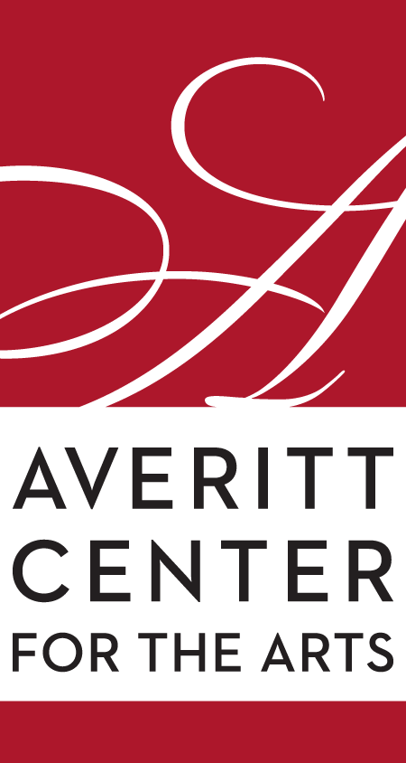
Rahn Hutcheson
Executive Director
Averitt Center for the Arts
P.O. Box 926 • 33 East Main Street
Downtown Statesboro • (912) 212-2787
www.averittcenterforthearts.org
rhutcheson@averittcenterforthearts.org

Summer Camps at the Averitt are here
Monday, May 30 was the opening date for the annual array of Averitt Center Summer Art Camps. During the nine weeks of summer, there are 58 week-long camps for children ranging from three-year old dancers to 18-year-old artists. There are two ceramics workshops for adults as well as one ceramics class.
Some of the summer offerings include:
Lego Camp, STEAM camp, Painting for Gamers, Art In Nature, Space Camp, Summer Ceramics Sampler, Lion King Kids, Modern Dance Camp, Camp 9 ¾, Mermaids and Pirates, Encanto Dance Camps, Magical Fairytale Camp and many, many more. For a complete list and descriptions of camps, visit our website at www.averittcenterforthearts.org/summer-camps.
The ACA Summer Art Camp program, which is sponsored by Synovus, provides kids from ages 3 to 18 with the opportunity to be creative, have fun, meet new friends and start or continue a life-long love of the arts. When you register your child or children for any of our 2022 summer camps, he or she will receive a free t-shirt with the Summer Camp logo emblazoned on the front. One free t-shirt per camper but additional t-shirts may be purchased.
To register, call the Averitt Main Desk at 912-212-2787 or Tony Phillips at 912-259-9228.
Week-long, full-day or half-day camps are available in the areas of visual arts, dance, theater and music. Tuition is $125 for half-day camps ($100 for members) and $175 for full-day camps ($150 for members). But, if you register your child or children 10 days or more before camps start, there is a $25 Early Bird Discount per camp.
Visit the Averitt Center website for full camp descriptions and get ready to spend the summer with us!
Cotton Rose School of Dance at the Averitt Center will hold its year-ending recital, Alice in Wonderland, on Saturday, June 4 at 7 p.m. Tickets are only $10 per person.
The first half of the show, which is sponsored by Jim and Betsy Nichols, is filled with Tap, Jazz, Hip Hop, Modern, and Lyrical dances. The music fits the Alice in Wonderland theme. After a 10-15 minute intermission, the second half of the show is ballet.
Featured performers are Anna Kate Croft (Alice), Tessa Salter (the White Rabbit, Caterpillar), Grace Ward (the Doorman), Rose Thompson (Tweedledee), Reagan Bond (Tweedledum), Ana Grace Evans (the Cheshire Cat/Alice’s Sister), Laural Boyles (the Mad Hatter), Annie O’Neill (the Queen of Hearts/Dodo Bird), Cindy Rodriguez (the March Hare), Nadilie Olson (the Doormouse) and Kyndle Jenkins (the Flamingo).
During the month, members of the Statesboro Youth Theater and the adult community theater will be rehearsing for July’s performance of The Wizard of Oz, which is sponsored by Morris Bank. The musical will hit the Emma Kelly stage on two weekends, July 15-17 and July 22-24.

