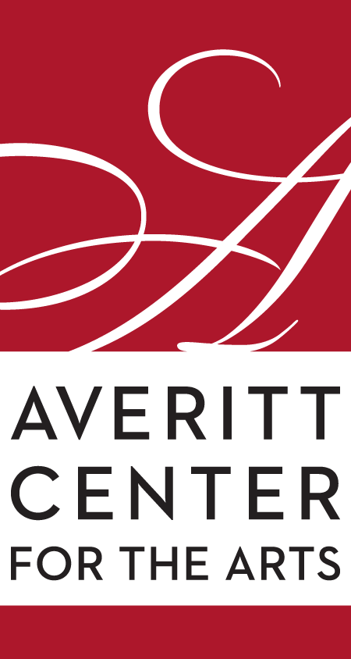
Rahn Hutcheson
Executive Director
Averitt Center for the Arts
P.O. Box 926 • 33 East Main Street
Downtown Statesboro • (912) 212-2787
www.averittcenterforthearts.org
rhutcheson@averittcenterforthearts.org

Follow The Yellow Brick Road
to the Emma Kelly Theater

Over 50 local and area adults and children will bring Dorothy, the Scarecrow, the Tin Man, the Cowardly Lion and the magical lands and residents of Munchkinland and Oz to life during the Averitt Center’s presentation of The Wizard of Oz on consecutive weekends in July.
Directed by Averitt executive artistic associate Robert Cottle, this community-theater production features all the memorable songs and phrases from the beloved musical. The shows, which are slated for July 15-17 and July 22-24, also feature all the loveable characters from the legendary movie, which is owned by the Turner Entertainment Company and distributed in all media by Warner Brothers.
Tickets for the reserved-seat performance are $25 for adults ($20 for ACA members, active and retired military, first responders, city of Statesboro and Bulloch County employees) and $15 for students. Curtain time for the Friday night performances are 7 p.m. while the Saturday and Sunday shows are 3 p.m. matinees.
Tickets can be purchased at the Box Office of the Averitt Center Main Gallery (open 9 a.m.-4 p.m. Monday through Friday), by calling 912-212-2787 or online at www.averittcenterforthearts.org. The Wizard of Oz is sponsored by Morris Bank and the accounting firm of Dabbs, Hickman, Hill and Cannon, LLP.
Cast members are:
Dorothy Gale: Julian Schwarz
Aunt Em/Glinda: Christie McLendon
Uncle Henry/Emerald City Guard: Kyle Stivers
Zeke/Cowardly Lion: Brandon Reaves
Hickory/Tinman: Todd Williford
Hunk/Scarecrow: Shanna Haselton
Miss Almira Gulch/The Wicked Witch of the West: Brandi Harvey
Professor Chester Marvel/The Wizard of Oz: John Parcels

Children's ensemble
Citizens of Munchkinland
Chorus Mayor: Jackson Gaines
Coroner: Camden King
Barrister: Siena Camiscioli
3 City Fathers: Noella Griswold, Charley Jane Burgess, Ella Sobaje
3 Tough Guys: Charlotte Bridges, Lola Schwarz, Jenna Best
Fiddler: Charlotte Wiggins
Braggart: Lilyann Gaschel
2 School Teachers: Catherine Haddad, Anna Grace Rollins
3 Tots: Chloe Best, Elsa King, Amayah Moore
Munchkin Townsfolk: Emsley King, Harper Pate, Muriel Graham, Adyson Graham, Ellie Spence
Adult ensemble
Trees and crows will also be the singing poppies and they will also be included in the Ozian chorus
Crows: Mackenzie Harvey, Liz Harvey
Trees: Julia Curiel, Elisabeth O’Quinn
​Ozians - Chorus
Beauticians: Sosi Sobaje, Ressie Fuller
Polishers: Emily Lloyd, Nicki Gibson, Anakade Clemen
Manicurists: Alison Darby, Cynthia Waters
Oz Man: Bobby Burgess
Oz Woman: Tara Jeffers
Winkies - Male Chorus: Matt Spence, Jamey Saunders, Bobby Burgess, Mike McLendon
Winkie General: Thom Mortimore
Nikko - Commander of the Monkeys: Charlotte Bridges
Jitterbugs & Ghosts - Chorus: Molly Peyton Griswold, Abbygale Lee Knight
Jitterbug - Lead Dancer: Claire Stafford

There are still four weeks of Averitt Summer Camps and 25 week-long camps for dancers, painters, potters and children who are just exploring their artistic sides.
Some of the summer offerings are:
Magical Fairytale Dance Camp, Painting for Gamers, Dinosaur Camp, Travel Through Time Art Camp, Minecraft Camp, Aristocrat Kids Theater Camp, Art Around The World Camp, Artsy Animals, Let’s Get Muddy, Under the Sea Dance Camps, and many more. For a complete list and descriptions of the camps, visit our website at www.averittcenterforthearts.org/summer-camps.
Registration continues for this annual program, sponsored by Synovus, which provides kids from ages three to 18 with the opportunity to be creative, have fun, meet new friends and start or continue a life-long love of the arts. To register, call the Averitt Main Desk at 912-212-2787 or Tony Phillips at 912-259-9228.
Week-long, full-day or half-day camps are available in the areas of dance, theater, music and visual arts. Tuition is $125 for half-day camps ($100 for members) and $175 for full-day camps ($150 for members). But, if you register your child or children 10 days or more before his/her camp starts, there is a $25 Early Bird Discount per camp.
Visit the Averitt Center website for full camp descriptions and get ready to spend the summer with us!

