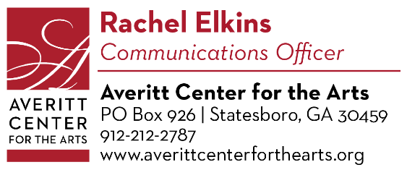
January Press Release

December 13, 2022

Ring in the New Year with the Arts!

Achieve your creative New Year’s resolutions at the Averitt Center for the Arts in 2023. We’ve got plenty of classes and events to help you start the year off right!

Want to learn something new or improve an old skill? Our theater, dance, and visual arts classes begin January 9th. Enrolling in art classes is one of the best investments parents can make in their child’s development.

January 12th at 5:30pm, we will host an opening reception for our Voices exhibition. This show was created to provide an opportunity for marginalized artists to engage our audience in conversations on identity, representation, validation, and history. This exhibition seeks to cultivate a space to celebrate BIPOC narratives and amplify voices of people of color in Statesboro. It features contemporary artworks across several mediums from artists Gabriel Diaz, D’Antre Harris, Johnesia Lucas, Nancey Price, and Danielle Scott.

Our Main Gallery at 33 E. Main St. is sponsored by Burney Marsh & John Tucker, Bill & Virginia Anne Franklin Waters, Lawrence & Kathleen Smith, Drs. Patrick & Theresa Novotny, The Statesboro Regional Art Association, and Frazier’s Flowers. Our current gallery exhibition, Somewhere in Between: Works by Colleen Beyer Stewart and Wesley L. Stewart, will still be available for viewing January 3rd – 6th. Our gallery events are free to the public.

January 13th at 6pm, we will have our monthly Paint-N-Party. No experience necessary! Just come and have fun with friends and your favorite drink! This month we will be painting a beautiful winter scene, featuring a cardinal. The cost to attend this event is $35 and includes all the supplies needed. Our Paint-N-Parties are held at the Roxy Remley Center at 31 E. Vine St. and are catered and sponsored by BOROTAKEOUT.

Also on the 13th, our ONE Series is back at 7:30pm in the Emma Kelly Theater (33 E. Main St.). ONE is a series of performances highlighting ONE gifted individual. This show will feature a conversation with and performance by Gazzie White. White is a Statesboro native who is known for forging a path past the traditional boundaries of artistry, especially in music. What started as a childhood passion for her, has matured into a skilled art, through mentorship, collaboration, and experience. White is known for her powerful voice and passion for inspiring people. Tickets are just $20. The ONE Series is sponsored by Brinson, Williams & Groomes Insurance.

Interested in pottery but feeling shy about signing up for a class? Come on down to the Roxie studio (31 E. Vine St.) and try our Give it a Spin! workshop on January 14th at 6pm. This 2.5-hour session will cover the basics of throwing on the potters’ wheel. All tools and materials provided. The cost is $40. Give it a Spin! is for ages 16 plus.

Celebrate the legacy of Martin Luther King, Jr. through the spoken word of poetry and prose on January 19th at 7:30 as we host our 8th annual Behold, Here Cometh the Dreamer in the Emma Kelly Theater (33 E. Main St.). This year’s esteemed, featured guest will be Dr. Alvin Jackson. Tickets are $20. Behold is sponsored by Davis Bozeman Johnson Law.

Finally, we will round out the month with a little jazz! Karla Harris and the Joe Alterman Trio will perform in the Emma Kelly Theater (33 E. Main) on January 21st at 7:30pm. This exciting combo first joined forces in 2020 at the Sandy Springs Performing Arts Center. But Harris (jazz vocalist) and Alterman (jazz pianist) are also well-known for their solo work. Tickets are $30. This concert is sponsored by Renasant Bank and Georgia Power.

For more information on events, classes, and workshops, visit our website at www.averittcenterforthearts.org or contact the Averitt Center at 912-212-2787.

